
The University of Azad Jammu & Kashmir
Name | Rizwan Ali
Roll No | 2025-SET-40
Lab No | 03
Instructor | Sir Fahad Nisar
Course | Software Configuration and Management Technologies

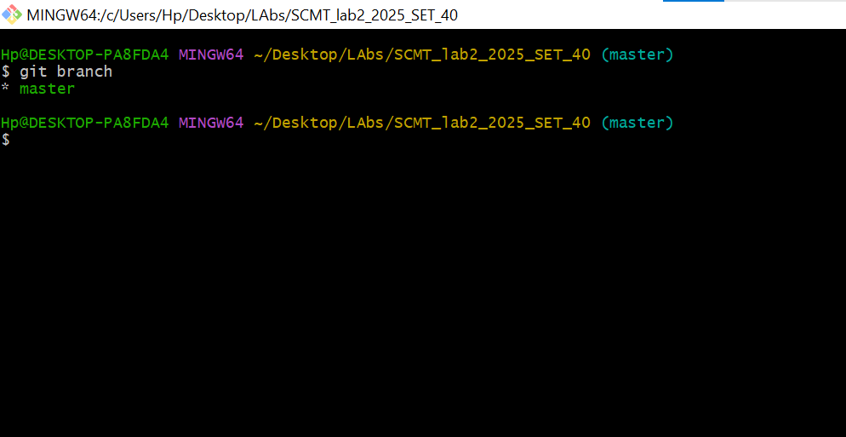
1.Branch creation & Active branch Verification

2. Committing file on Feature Branch
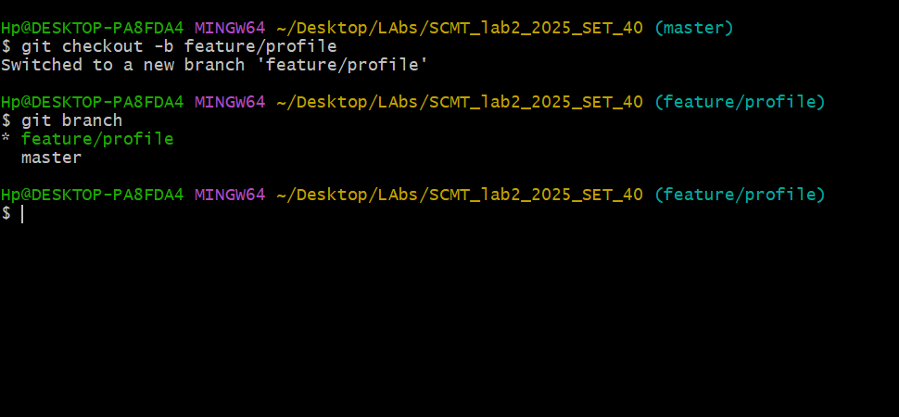

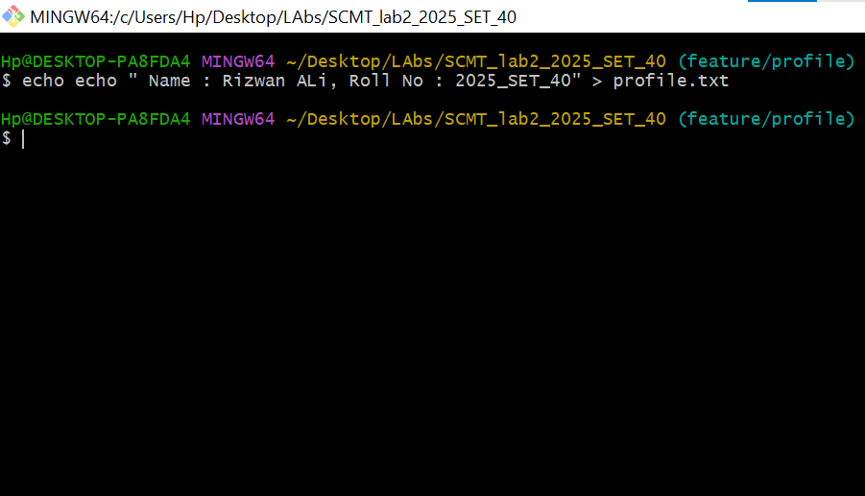
3.Creating Profile.txt With Name & Roll No

3. Switching To Main Branch & Merging

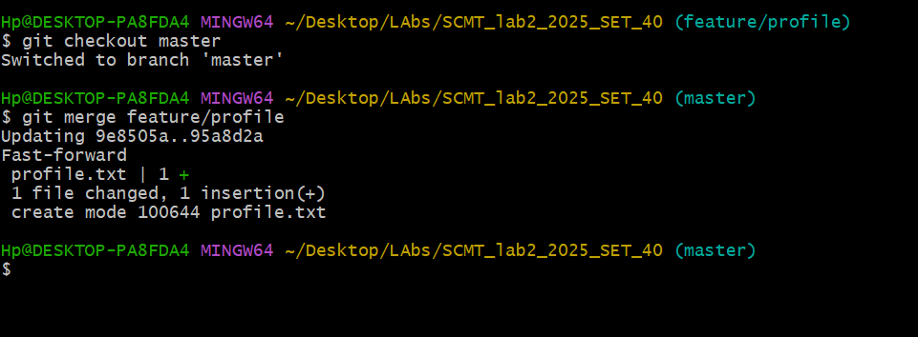

4. Branch Deletion

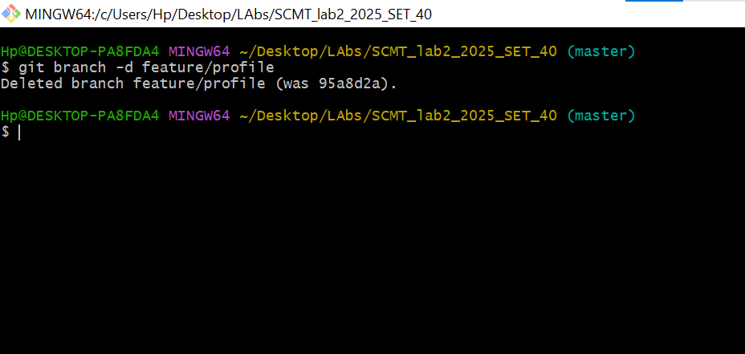

6.Visual Git Log History

